# Quick Guide to RLNN Software

**Prerequisites Libraries Required**: MLPack, Boost, Armadillo libraries

**Top Level CPP File**: rlnn4/RLNNCognitiveEngineTester_v2.cpp

## 1.) Setting up System/Simulation Parameters

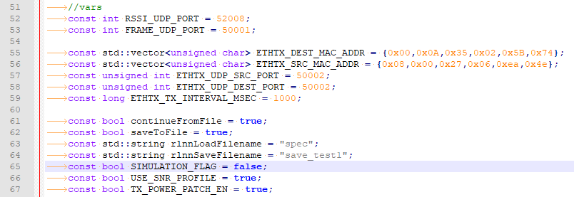

RSSI_UDP_PORT: ViaSat modem port for receiving RSSI updates  
FRAME_UDP_PORT: ViaSat modem port for receiving raw frames  
ETHTX_UDP_SRC_PORT: Source port for sending to ML-605  
ETHTX_UDP_DEST_PORT: Destination port for sending to ML-605  
ETHTX_TX_INTERVAL_MSEC: deprecated

saveToFile: flag to save cognitive engine parameters to a file to be continued from in the future  
rlnnSaveFilename: filename of cognitive engine parameters to be saved  
continueFromFile: flag to continue cognitive engine from a previous run  
rlnnLoadFilename: filename of previously saved cognitive engine parameters

SIMULATION_FLAG: False if using with ML-605/ViaSat or ARCC hardware. True if running without any hardware  
USE_SNR_PROFILE: True if using a custom SNR profile (named “snrProfile.txt”); False if using default linear ramp up and down profile. snrProfile.txt is a text file where each line is a EsN0 recording in dB.  
TX_POWER_PATCH_EN: True to override the cognitive engine’s tuple decisions to only jump TX power by at most 1.5 dB between each tuple. False to disable.

## 2.) Setting up Cognitive Engine Parameters

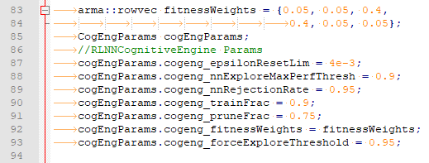

_fitnessWeights: Multi-objective weight vector whose elements must sum to 1. The weights are {THROUGHPUT, BIT ERROR RATE, TARGET BANDWIDTH, SPECTRAL EFFICIENCY, TRANSMIT POWER EFFICIENCY, DC POWER CONSUMED}

_epsilonResetLim: Explore/Exploit Epsilon minimum value. On each iteration, epsilon continues to decrease. It resets to when it reaches epsilonResetLim  
_nnExploreMaxPerfThresh: when exploring, we threshold into two bins (good and bad actions). Good actions are defined as actions whose expected performance is _nnExploreMaxPerfThresh*max(performances of all possible actions).

_nnRejectionRate: probability of choosing from the good bin of explorable actions.  
_trainFrac: Fraction of the training set to use for training. 1-_trainFrac is used for validation data  
_pruneFrac: Fraction of the training buffer that we keep in the training buffer after a successful training process has occurred. (We eliminated 1-_pruneFrac from the buffer)

_forceExploreThreshold: if the performance difference between two consecutive recorded samples is >= _forceExploreThreshold, then the cognitive engine is forced to throw away its buffer and re-explore the space.

## 2.) Setting up Neural Network Parameters (optional)

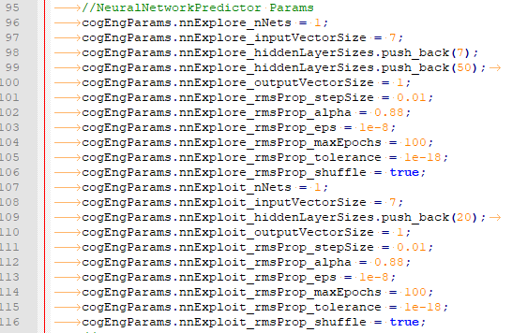

nnExplore_nNets: number of parallel explore NNs in the Explore NN ensemble  
nnExplore_inputVectorSize: number of neurons in the input layer of an Explore NN  
nnExplore_hiddenLayerSizes: vector holding the number of neurons in each hidden layer of an Explore NN  
nnExplore_outputVectorSize: number of neurons in the output layer of an Explore NN  
nnExplore_rmsProp_*: deprecated

nnExploit_nNets: number of parallel exploit NNs in the Exploit NN ensemble  
nnExploit_inputVectorSize: number of neurons in the input layer of an Exploit NN  
nnExploit_hiddenLayerSizes: vector holding the number of neurons in each hidden layer of an Exploit NN  
nnExploit_outputVectorSize: number of neurons in the output layer of an Exploit NN  
nnExploit_rmsProp_*: deprecated

## 3.) Setting up Application Specific Parameters

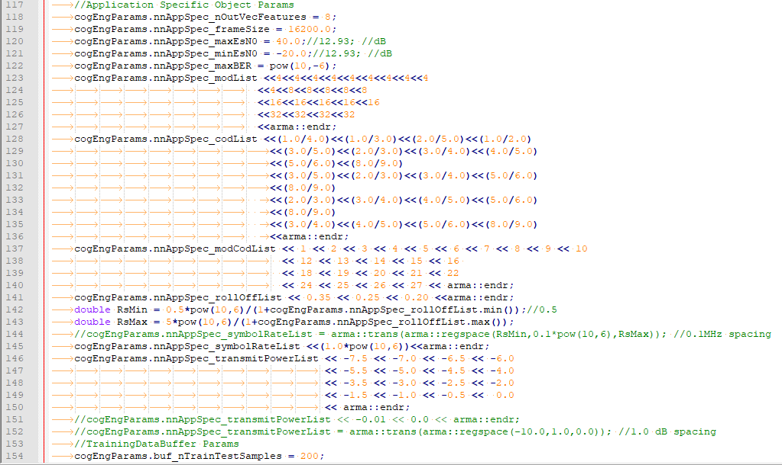

_nOutVecFeatures: number of output vector features in training buffer (see Application Specific Module for details on these 8 features)  
_frameSize: number of bits in DVB-S2 frame  
_maxEsN0: maximum expected/possible EsN0 reading in run (used as a scaling factor) (in dB)  
_minEsN0: minimum expected/possible EsN0 reading in run (used as a scaling factor) (in dB)  
_modList: vector of number of symbols for each modCod pair  
_codList: vector of code rate for each modCod pair  
_modCodList: modCod ID numbers that correspond to the modCod pairs in _modList and _codList  
_rollOffList: Allowable filter rolloff values  
_symbolRateList: vector with all allowable symbol rates. On-the-fly symbol rate changes is not supported by DVB-S2. This vector should be a vector of one value for flight tests; for simulation, this can be any vector of symbol rates.  
_transmitPowerList: vector of allowable relative transmit powers (dB).

## 4.) Setting up Training Buffer Parameters



_nTrainTestSamples: Number of samples in the training buffer.

## 5.) Running the Code

Compile the code in Linux and then run it from a terminal (“./RLNNCognitiveEngineTester_v2”). The output of the run is outputted to the terminal. A log file (logging.txt) is also written with more information.